User Feedback

Form Link 🡪 <https://forms.gle/N48T7zrUNnZjHtFR7>

I have distributed the above link to 5 people who are related to the Tea selling field

**Form:**

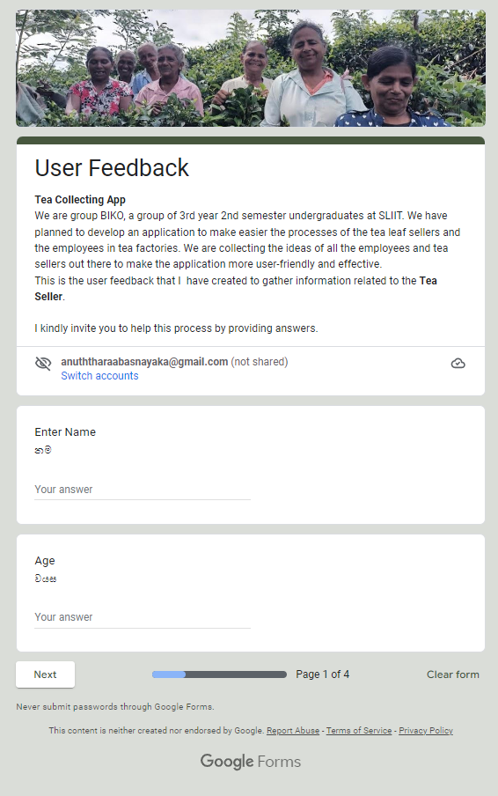

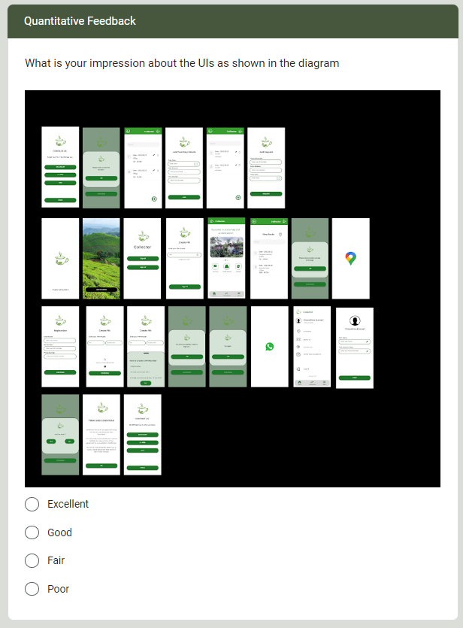

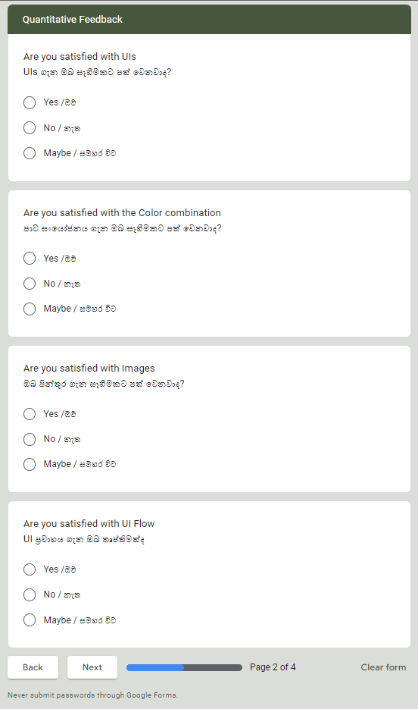

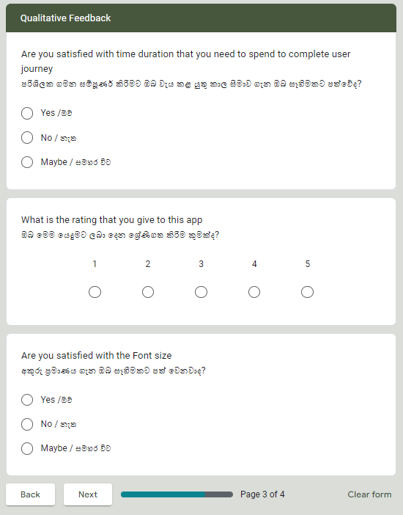

Responser:

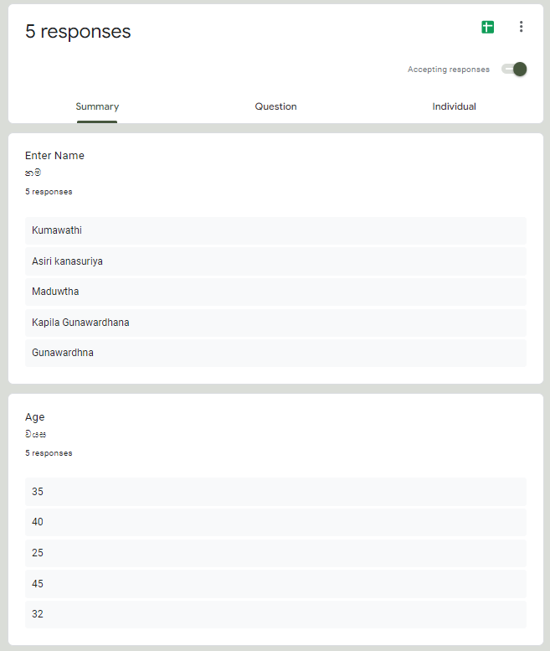

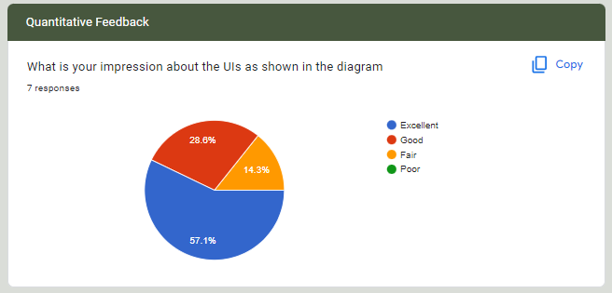

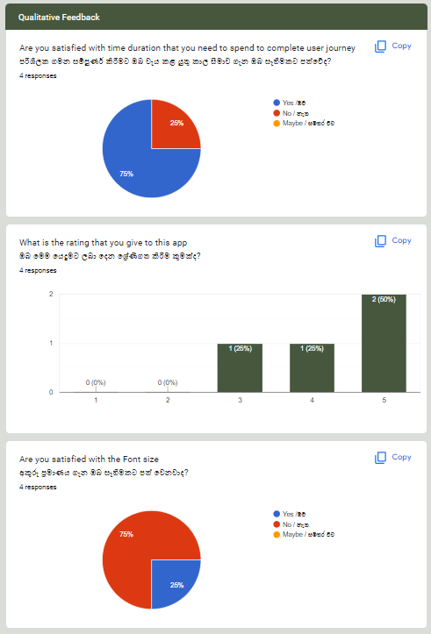

According to the user feedback 90% of both qualitative and quantitative factors are fulfilled

In here we consider the Likes and dislike impressions and requests that are gain from the customer and they requested some improvements.

**Conclusion:**

* Need to change the front size
* Use Vectors rather than using Text labels